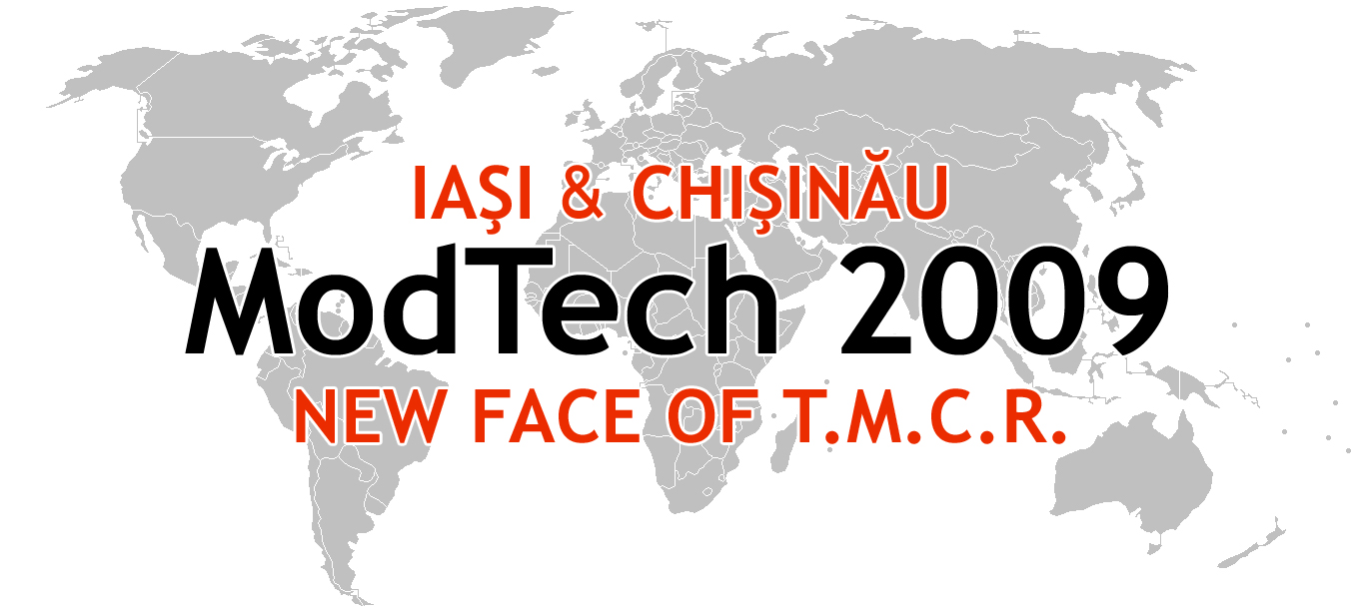

ModTech International Conference - New face of TMCR
Modern Technologies, Quality and Innovation - New face of TMCR
21-23rd May 2009
http://www.modtech.ro

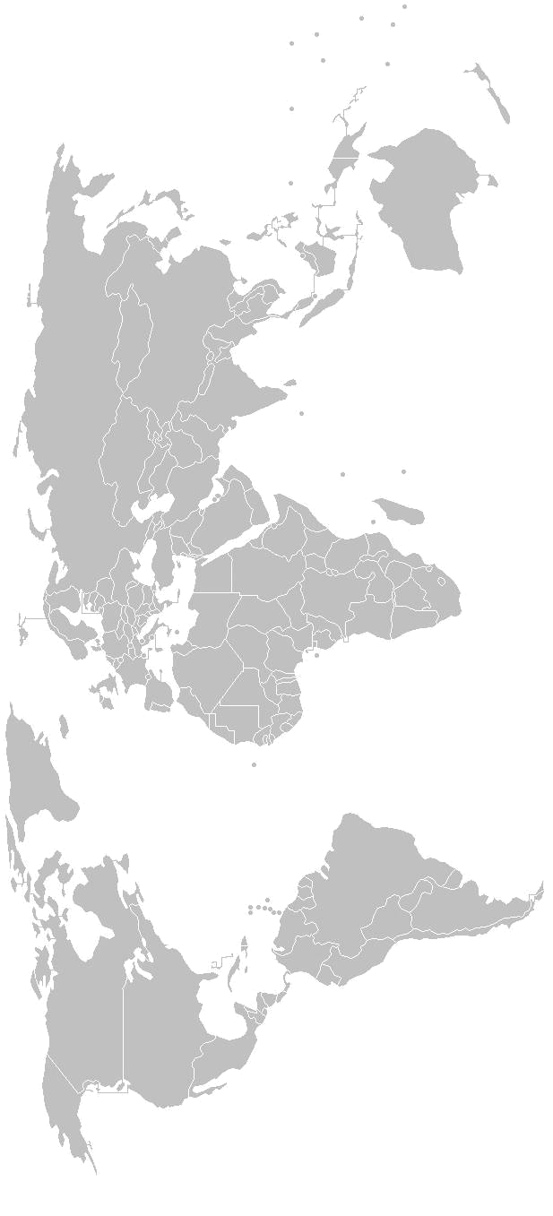
SECTION 5
Materials, Processes and Innovative Technologies

A-2-09, Laboratory of Automation and Robotics in Technology

Chair: Prof. Traian Gramescu, Ph.D.
Co-Chair: Assoc. Prof. Viorel Cohal, Ph.D.
Secretary: Catalin Mocanu, Ph.D. Student

Thursday  May 21 | Papers & Authors
15²⁰-15³⁵ | Tailoring the interface for fabric based epoxy composites  Adrian Cîrciumaru, Iulian-Gabriel Bîrsan, Vasile Bria & Victor Ungureanu
15³⁵-15⁵⁰ | Use of the law of mixtures in the mechanical identification of the composite materials Anghel Chiru, Sorin Vlase,Leonte Petric, Arina Modrea,Ioan Pirnă&Virgil Mihălcică
15⁵⁰-16⁰⁵ | Human identification using body segments movement analysis  Chiru Anghel, Mihălcică Mircea, Dumitru Nicoară
16⁰⁵-16²⁰ | Innovative materials selection for competitive advantages  Eugen Axinte, Sorin Popa, Gheorghe Nagîţ , Juan Manuel Sala Gil , & Lorica Axinte
16²⁰-16³⁵ | Aspects regarding the materials in the process of ecoproducts designing  Lucian Barsan, Anca Barsan & Codruta Bolos
16³⁵-16⁵⁰ | Improvement of product quality based on taguchi method  Nadia Belu, Daniel-Constantin Anghel, Ilarion Banu & Sorin Ilie
16⁵⁰-17⁰⁵ | Inspection with infrared thermography of layered and hibryd composite materials using lockin method  Andreea Borîtu, Viorel Anghel, Nicolae Constantin, Mircea Găvan, Dragoş Tănase & Dan Codruţ
17⁰⁵-17²⁰ | Determination of residual stresses and springback generated by tensile loadings in metal sheets  Gheorghe Brabie & Neculai Nanu
17²⁰-17³⁵ | Estimating the statistical parameters for data samples in an experimental installation Mihaela Rodica Clinciu
17³⁵-17⁵⁰ | Analysis of the reliability of the water meters using the faults tree method  Mihaela Rodica Clinciu
17⁵⁰-18⁰⁵ | Stand for the rotative boring of soft rocks  Cozma Bogdan-Zeno, Dumitrescu Iosif
Friday  May 22 | Papers & Authors
9⁰⁰-9¹⁵ | Representations of chaotic systems dynamics, with application in technological system stability control  Gabriel Frumuşanu
9¹⁵-9³⁰ | Material quality influence on petrotub casing joints functioning  Stefan Grigoras, Cristel Stirbu & Lucian Constantin Hanganu
9³⁰-9⁴⁵ | Contributions to ring spinning frames dynamics  Lucian Constantin Hanganu
9⁴⁵-10⁰⁰ | Specific aspects on yarn tensions produced during the ring spinning frames operating Lucian Constantin Hanganu, Carmen Loghin & Vasile Ciprian Stamate
10⁰⁰-10¹⁵ | Dynamics of yarns produced on ring spinning frames – a mathematical model  Lucian Constantin Hanganu, Ştefan Grigoraş & Gelu Ianuş
10¹⁵-10³⁰ | The study of sloshing in the parallepiped container  Alexandru Ioan, Leonard Domnisoru & Dumitru Dragomir
10³⁰-10⁴⁵ | Contributions to the improvement the nickel bronze graphite composite materials for friction applications  Ivănuş Radu Cristian
10⁴⁵-11⁰⁰ | Optimisation of a milling process based on simulated response surface methodology Ricardo Morgado, Laurenţiu Slătineanu, António Gonçalves-Coelho & António Mourão
11⁰⁰-11¹⁵ | The importance of ecology as collective descriptive and experimental knowledge in industrial design  Monica Pop, Jeni Pralea & Magda Sficlea
11¹⁵-11³⁰ | Conceptual routes in the design process intended for the ecological product  Jeni Pralea, Magda Sficlea & Monica Pop
11³⁰-11⁴⁵ | The raise in quality of the industrial product by using certain ecological materials, technologies and strategies  Jeni Pralea, Magda Sficlea & Monica Pop
11⁴⁵-12⁰⁰ | Heating radiant systems manufactured from advanced composite materials  Dorin Rosu, Horatiu Teodorescu-Draghicescu, Sorin Vlase, Maria Luminita Scutaru & Alexandru Teisanu
12⁰⁰-12¹⁵ | Clutch wear diagnosis using fuzzy techniques  Ioan Ţarcă, Florin Blaga, Voichiţa Hule & Alexandru Pele
Lunch break
15²⁰-15³⁵ | Designing of an experimental stand for development of a revolute joint driven by pneumatic artificial muscles  Liliana Dragan, Ioan Nicoara & Flavia Chira
15³⁵-15⁵⁰ | Method to determine the theoretic burn temperature of gases in the cartridge  Tudor Cherecheş, Tiberiu Homutescu
15⁵⁰-16⁰⁵ | Method to determine the grende motion law in the barel of gun  Tudor Cherecheş, Tiberiu Homutescu
16⁰⁵-16²⁰ | Modeling through the fea method of the braided artificial muscle  Liliana Dragan, Horia Cioban & Flavia Chira

